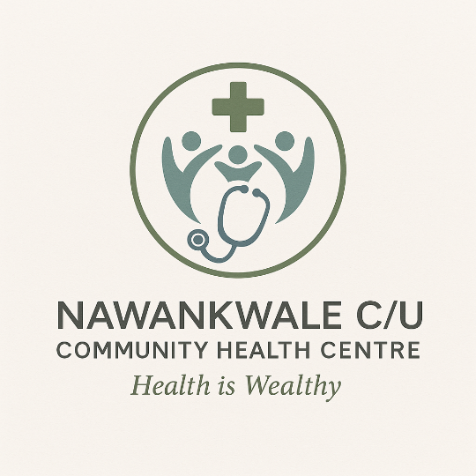

**Mobile Health Outreach Report**

**Report Title:** Mobile Health Outreach Activities in Nawankwale and Surrounding Villages

**Reporting Period:** February – May 2025

**Prepared by:** Kintu Yeko – Project Coordinator  
**Contact:** +256773854297 / [kintu.yeko@yahoo.com](mailto:kintu.yeko@yahoo.com)

Table of Contents

1. Background and Objectives 3

2. Outreach Locations and Dates 3

3. Services Delivered 4

4. Impact and Outcomes 4

5. Challenges Encountered**.** 4

6. Recommendations 4

7. Conclusion 5

8. APPENDIX. 5

## 1. Background and Objectives

Due to the delayed completion of the Nawankwale Community Health Centre, mobile health outreaches were conducted to meet the urgent healthcare needs of the Nawankwale and neighboring communities. The key objectives were:

* To improve access to basic healthcare services.
* To raise awareness on key health topics, including malaria prevention, maternal care, and hygiene.
* To provide early treatment and referrals where necessary.
* To build trust and awareness around the upcoming permanent health facility.

## 2. Outreach Locations and Dates

|  |  |  |  |
| --- | --- | --- | --- |
| **Village** | **Date of Outreach** | **Estimated Attendance** | **Key Services Offered** |
| Nawankwale | 10 February 2025 | 320 people | Malaria testing, antenatal care, deworming |
| Bugwere | 24 February 2025 | 180 people | Immunizations, HIV testing, family planning |
| Bunyambago | 16 March 2025 | 240 people | Health education, child nutrition, referrals |
| Naluko-mubalala | 6 April 2025 | 210 people | General checkups, hygiene sensitization |
| Nawankwale (Follow-up) | 3 May 2025 | 300 people | Wound care, follow-up consultations |

## 3. Services Delivered

* **Consultations:** 950 individuals received basic checkups and primary healthcare.
* **Malaria Screening:** 400 people tested; 128 treated on-site.
* **Maternal & Child Services:** 112 mothers received antenatal care and safe delivery kits.
* **Deworming & Vitamins:** Administered to 180 children under 12.
* **HIV Counseling & Testing:** 140 people tested and counseled.
* **Health Education Sessions:** Conducted on sanitation, handwashing, nutrition, and disease prevention.

## 4. Impact and Outcomes

|  |  |  |
| --- | --- | --- |
| **Key Area** | **Outcome** | **Unit of Measurement** |
| Access to Healthcare | Reached underserved villages | 5 villages served |
| Individual Beneficiaries | Residents directly supported | 1,250 people |
| Health Education | Sessions conducted | 6 group sessions |
| Referrals Made | Serious cases referred to Iganga District Hospital | 36 patients |

5. Challenges Encountered**.**

* Limited transport logistics and medical supplies constrained coverage.
* Poor road infrastructure delayed access to some remote locations.
* Shortage of volunteers during peak outreach activities.

## 6. Recommendations

* Seek funding for a dedicated outreach vehicle and fuel costs.
* Train local volunteers to support mobilization and record-keeping.
* Strengthen partnerships with district health services for referrals and technical support.
* Include mobile outreach as a recurring component even after centre operationalization.

## 7. Conclusion

The mobile outreach program served as a critical interim measure while the health centre is under construction. It built awareness, delivered vital care, and strengthened trust in the upcoming Nawankwale C/U Community Health Centre. With continued support, the facility will scale this impact through permanent, sustainable services.

## 8. APPENDIX.

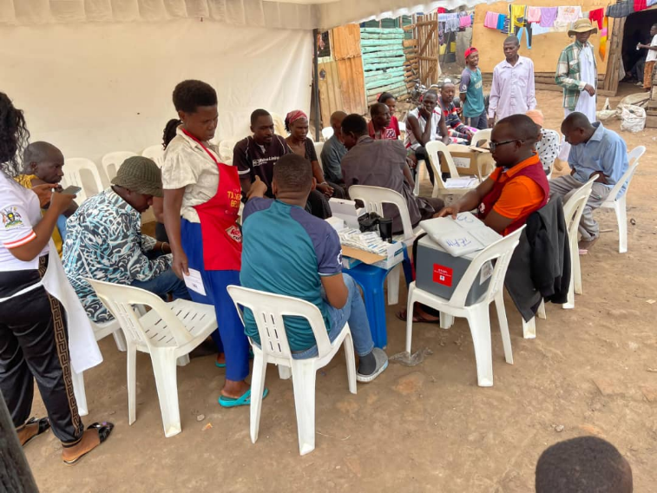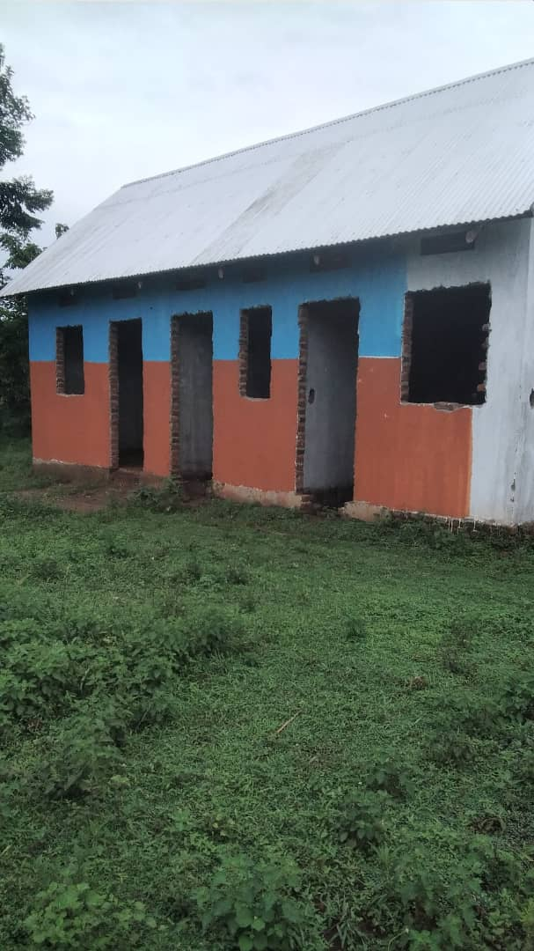

**Outreach session at Nawankwale trading centre. View of the building under construction.**

Bottom of Form